Customer:
Main Line Health

Business Problem:
Main Line Health is a large health care system in the greater Philadelphia-area. They mostly use their intranet to provide information quickly to medical staff working directly with patients. Their previous intranet was bogged down with different links lists across various pages. Users would often bookmark a particular page and bombard the links list without much organization. This created inconsistent information, bad links, old document versions, and a general scramble to get information while trying to provide patient care.

Solution:
Affirma designed a Resources mega menu from the global navigation that allows MLH to organize their links into categories: Administrative, Clinical, Education, and Other. The organization no longer has to worry about which, if any, page a user has bookmarked as a favorite since the global navigation is persistent across all pages in the intranet. This also centralizes and streamlines the latest and greatest information for the whole organization. Leadership and subject matter experts have permissions to manage this list, and the best part is that the intranet is responsive – so healthcare providers who favor their hospital-issued iPhone or iPad can just as easily access these resources.

Desktop:

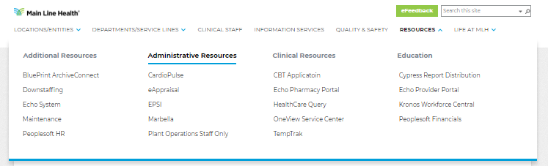

Mobile:

